A BOOK REVIEW OF
“UNABRIDGED DICTIONARY OF THE SENSATION AS IF”
BY DR. JAMES WILLIAM WARD

DR. RAJ K PANDIT. M.D.(HOM.)
Dept. of case taking and Repertory
raj.dr2609@gmail.com

DR. SWATI PANDEY. M.D.(HOM.)
Dept. of case taking and Repertory
pswati00098@gmail.com

Mahesh Bhattacharyya Homoeopathic Medical College & Hospital
(Govt. of W.B.)

A BOOK REVIEW OF
“UNABRIDGED DICTIONARY OF THE SENSATION AS IF”
INTRODUCTION:
The book“UNABRIDGED DICTIONARY OF THE SENSATION AS IF” was written by Dr. James William Ward. The Word UNABRIDGED means something that is written or published without being shortened in any way. This book must have published in the late 1930s.This repertory belongs to the Puritan group of repertory. This book is another avenue of approach to the traditional problem of remedy selection from the vast homoeopathic symptomatology.
ABOUT THE AUTHOR:
Dr. James William Ward wasborn in March 14, 1861 at Minneapolis, Minnesota. Ward received his medical degree from New York Homoeopathic Medical college and Hospital in March 15, 1883.
In 1883 Dr. Ward was resident physician to Ward’s Island Homoeopathic Hospital, and in 1895 he spent six months in Europe perfecting his professional education; and again in 1901 he went abroad for further study in Vienna, Berlin and Berne.
He has served as Surgeon to the City and Country Hospital of San Francisco, the Fabiola hospital of Oakland, and the Hahnemann Hospital of San Francisco.
Ward was described as “short, energetic, and Vital. To the end of his days he retained a well –earned reputation as a great ladies’s man”.
His final work, The Unabridged Dictionary of Sensations “As if” was completed just two weeks before his death. The compiling of this great work required the patience of a superman but it was done, and perhaps it was an indirect cause of undermining that marvelous physique that finally succumbed on July 12, 1939, just eight hours after he had finished a busy day at the office.
CONTENTS OF THE BOOK:
1. Foreword
2. Preface
3. Acknowledgment

4.Parts of the Book-3 parts
Part I- Pathogenetic(pg 1-960)
Part II- Clinical(pg961-1627)
Part III- Bibliography(pg1629 -1637) [ Included in the second part]
FOREWORD
The foreword is written by Dr. WILLIS A. DEWEY. This volume contains a vast amount of pathogenetic and clinical symptomatic information of the Materia Medica.
In this work will be found the results of the provings of many remedies by large groups of provers, with the detail of symptoms in their own language.
This work contains all the provings by Hahnemann and his contemporaries on down to the present time, making it necessary to discard every effort previously attempted and proceed with a more extensive research.
He has termed that the research involved in the preparation of this book has covered the extensive library of the Homoeopathic Foundation of California, the second largest collection of Homoeopathic literature in the United States and was carried on for a period of over six years, the results of the first two of which could very aptly be termed as "love's labor lost."
According to Dr. Dewey, the Materia Medica has been a life-long study of Dr. Ward's from his college days when, under the unusual opportunities of study and association with Timothy F. Allen, St. Clair Smith and Martin Deschere, an unbounded interest was aroused to facilitate choice of the remedy at the bedside.
The dominant purpose of this book has been to present the symptoms in that orderly way which may assist the physician in his effort to quickly choose the similimumhomoeopathically necessary to be curative.
PREFACE:
Preface contains Sources, plan and construction.
Sources:
The Pathogenetic or first division of the book comprises a summary and thorough research of the original provings as found in-
1. Timothy F. Allen's "Encyclopedia of Pure Materia Medica."
2. T. L. Bradford’s collection, "Index of Provings”, up to and including the year 1879.
3.The symptoms mentioned with sensations as if in “Hahnemann’s Materia Medica and Chronic Disease”.
4. J. H. Clarke’s Dictionary of Materia Medica.
5.Collected the symptom-descriptions of provings widely distributed throughout the Journals, Transactions of the American Institute of Homoeopathy, the proceedings of the International Hahnemannian Association, and Extensive English Literature of the Homoeopathic school.
The Clinical or second division of the book is a record of diversified verifications developed through:
1. Clinical experiences and observations of many distinguished contributors to the symptomatology of our Materia Medica.
2. The "Guiding Symptoms" of the stalwart American Homoeopath, Constantine Hering, have been made the basic record of this part of the book.
3. The writings, lectures and records of others have contributed to the fullness of it.
The Bibliography, or third part, makes acknowledgement of the sources from which symptom-descriptions have been obtained.
Individual provers consulted have been given full credit for their provings or clinical recordings wherever any sensation-description has been appropriated.
Plan and Construction:
Dr. Ward says, since this work differs in many important particulars from any of a similar character hitherto published, it may be necessary to state the principles of its construction.
The volume here offeredis a directory of special symptoms containing the name of the remedy in the pathogenesis of which a certain phraseology is found.
He also says that these morbid symptoms are described as sensations felt, either in the process of proving of remedies or in the course of clinical experience with them, and are generally expressed by the phrase "as if" or "as though”.
FOR EXAMPLE-
Abdomen Burst.-Colic, as if the abdomen would burst asunder. Coffea Cruda(A)Pg 2
Abdomen Burst.-He screams on account of pains, which seem as though they would burst the abdomen. Hyoscyamus (A)Pg2
He further says that the purpose of this dictionary is to make easily available certain symptomatic-descriptions expressed by the provers in the subjunctive mood and, furthermore, to record for clinical application the proved relationships between those symptoms and their remedies.
The method chosen for accomplishment was to systematically caption and cross-caption these sensation-described symptoms, so that each of them falls naturally into its own alphabetical place in an orderly arrangement, making it as readily found as a word in an encyclopedia.
FOR EXAMPLE-
CAPTION | CROSS-CAPTION
Abdomen Cold.- Cuttings in the abdomen as if from taking cold. Aloe (A) Pg 2 | Cold Abdomen.- Colic as if after taking cold, in the abdomen. Carbo Vegetabilis(A) Pg 175
AbdomenBruised.-Pain in the abdominal walls, as if bruised when gasping..Pulsatilla(H) Pg 1 | Bruise Abdomen.-Twisting digging pain in the upper abdomen, as if from a bruise. Cina (A)Pg 115
Abdomen Cutting .- Cutting and pinching in the abdomen as from flatulence, or cold.Anacardium (A) Pg 3 | Cutting Abdomen .- Cutting in the abdomen, as if after a cold. Arnica (A) Pg 224
Ball Abdomen.- Sensation as of a ball ascending from the abdomen into the throat. Argentum Nitricum(A) Pg 49 | Abdomen Ball.- Constant tearing colic in the side of the abdomen, as if the parts were rolled up into a ball. Chamomilla(A)Pg 1
Cobweb face.- Feeling as if a cobweb , or the white of egg, were on the skin of the face. Baryta Carbonic(Hg)Pg 174 | Face Cobweb.- Sensation as of a cobweb or white of egg on the skin of the face. Alumina (JHC)Pg 311

Each symptom is so described that no matter under how many alphabetical heads it may appear, the indicated remedy and key to the authority for it is always given by an initial, letter or letters in parentheses immediately following the remedy and printed in italics.

FOR EXAMPLE-
Abscess Chest.-Deep-seated pain, as if from an abscess in the right side of the chest. ChelidoniumMajus(A)

Abscess Chin.-Inflammatory swelling beneath the chin, as if an abscess would form, with burning pain. Causticum (A)

Abscess Ear.-A stitch in the inner ear and a sensation of warmth in it, with a sensation as though an abscess would open. Bryonia (A)

Abscess Ear.- Throbbing pain in the left ear, as if from an abscess. Gambogia (A)

Abscess Ear.-The swelling about the ear increased for three days, and looked as though it would break on the outside. Tuberculinum (HCA)

Abscess Ears.-Left-sided earache, as if from deeply-seated abscesses. Robinia (A)

Abscess eye.-Swelling and pains as if an abscess would form in the right eye. Anantherum(A)

Abscess eyes.-Stinging in the eyes, as if from abscesses. Robinia(A)

The name of the author, designated by the initials, is given in the third part of the book, the Bibliography.
FOREXAMPLE-
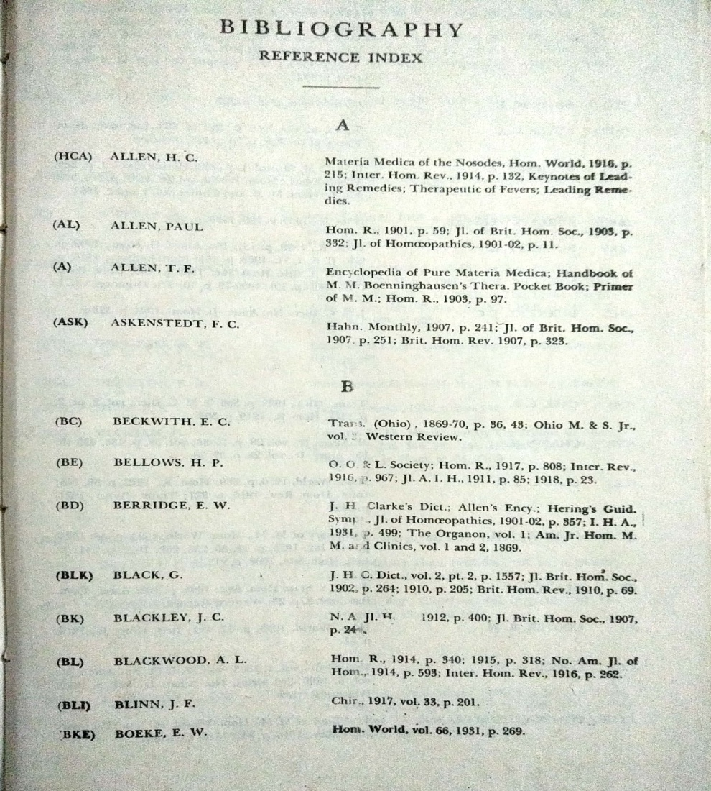
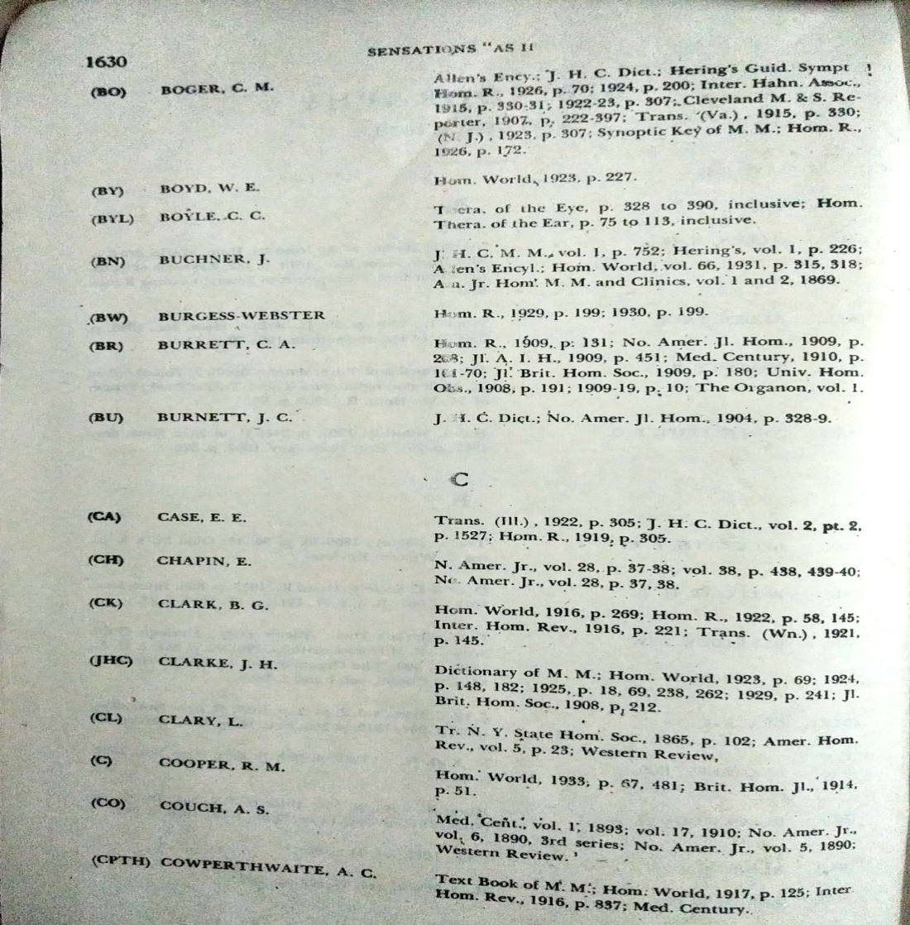
Cross-references to the sensation-descriptions are numerous throughout both divisions of the book. In a number of instances in the clinical section a symptom will be found under as many as five different captions. For example-
"Nails grey, dirty as if decayed; when cut scattering like powder and splitting into layers." will be found under the captions:
Decayed Nails; Nails Dirty-Grey; Powdered Nails; Splitting Nails; Scattering Nails.
FOR EXAMPLE-
“Nails grey, dirty as if decayed; when cut scattering like powder and splitting into layers."
Decayed Nails.-Nails grey, dirty, as if decayed; when cut scattering like powder and splitting into layers. Silica (Hg) Pg 1124
Nails Dirty Grey.-Nails grey , dirty ,as if decayed; when cut scattering like powder and splitting into layers. Silica (Hg)Pg 1327
Powdered Nails .- Nails grey , dirty ,as if decayed; when cut scattering like powder and splitting into layers. Silica (Hg) Pg 1372
Splitting Nails .-Nails grey , dirty ,as if decayed; when cut scattering like powder and splitting into layers. Silica (Hg) Pg 1473

The topographical arrangement under anatomical headings has not been extensively followed, rather a most individually descriptive word of the sensation-symptom has been chosen for the caption in each case.
Where several captions are identical the remedy for each has been placed in alphabetical order.
FOR EXAMPLE-
Burst abdomen.-Pg 136-137
Burst Abdomen.-Weight in the abdomen, as of a load, with anxiety as if the abdomen would burst. AmmoniumMuriaticum (A)
Burst Abdomen.-Pressure in the region of the navel as if something hard had formed there, with a sensation when breathing, speaking, and especially when coughing as if the abdomen would burst. Anacardium (A)

Burst Abdomen.-Feeling as if the abdomen would burst before stool. Arsenicum Album (JHC)

Burst Abdomen.-A feeling of fulness above the pubes, as though everything was stopped and the abdomen would burst. Baryta Carbonica(A)

Burst Abdomen.-In the evening after eating soup, the abdomen feels full, as if it would burst, disappearing in an hour. Castoreum (A)

Burst Abdomen.-The abdomen felt as if it had been crammed full, as if it would burst, with constant unsuccessful desire to be relieved by eructations.Causticum(H)

Burst Abdomen.-Distension of the abdomen, as if he would burst, after a moderate meal.Dulcamara(A)
Burst Abdomen.-Sudden distension of the abdomen, as if it would burst, disappearing after emission of flatus. Kali Iodatum(A)

Burst Abdomen.-Sensation while walking as if the abdomen would burst. Lac Caninum (JHC)

Burst Abdomen.- Sharp pressure in all the parts of the abdomen from within outward as if the abdomen would burst. Magnetis Polus Arcticus(H)

Burst Abdomen.-Pressive pain in the abdomen, as if everything would burst out. Moschus (A)

Burst Abdomen.-Excessive distension of the abdomen, as if it would burst; only slightly relieved by the emission of flatus. Natrum Carbonicum (A)

Burst Abdomen.-Flatulent distension and tension of the whole abdomen, as though it would burst with movements in it and emission of flatus, during the menses. Niccolum(A)

Burst Abdomen.-Violent cramplike pain in the lower abdomen, as if the abdomen would burst, with constant eructations. NitricumAcidum(A)

Burst Abdomen.-Sensation in the abdomen of distension as if it would burst. OviGallinaePellicula(JHC)

Burst Abdomen.-Pain as if something in the abdomen had burst. Phosphorus (H)

Burst Abdomen.-Hard distension of the abdomen, with tense pain in it, and a sensation as if the abdomen would burst. Pulsatilla(A)
Burst Abdomen.-Excessive distension of the abdominal parietes , as if she would burst. Sabina (A)

Burst Abdomen.-Painful pressure in the lower abdomen, as if it would burst before a soft stool, after which it was somewhat relieved. Spigelia (A)

The rule adopted for the preparation and arrangement was to make a verb, adverb or noun in the sentence the leading word in the caption, two or three words of a sentence having suggested the captions which have been employed.
FOR EXAMPLE-
Pg 159
Chest Pressed.-Constriction about the middle of the chest , as if pressed together ,with short breath . Magnesia Carbonica(A)

Chest Pressing .- It seems as though something were pressing on the chest, after dinner.ChelidoniumMajus(A)

Chest Pressive .- After half an hour the sensation as of a ball in the stomach disappeared and gave place to a severe pressive pain in the left side of the chest . Bryonia (A)

Chest Pressure .- Much constriction in the chest afterwds becoming a pressure ,and returning in the afternoon as a sticking. Iodum(A)

The cross-captions render the identification of the symptoms easier, and also, in a like manner, the words of the caption often convey the true meaning of the sentence.
The interrogation of the patient will naturally evoke in the physician's mind the words most characteristic in their description.
The art involved was to translate the language of the patient into descriptive captions, thereby establishing a correlation between the salient words of the patient and captions of proved and clinical symptoms.
The elaborate symptomatic expressions as shown in this volume should convince the reader of the variety of sensations experienced and often extravagant language used by drug provers.
The apparent trivialities in the peculiar "symptom expressions" are the recorded words of the provers and comparable to the descriptions given by the patients in our every-day practice.
The Pathogenetic or first division of the book comprises a summary of original provingsof Timothy F. Allen's "Encyclopedia of Pure Materia Medica”, T. L. Bradford's "Index of Provings" up to and including the year 1879, and Wherever Hahnemann has written in his Materia Medica Pura or in the Chronic Diseases symptom-descriptions embracing the words "as if" they have been given priority by the author and substituted for similar sensation-symptoms found elsewhere.
FOR EXAMPLE-
UNABRIDGED DICTIONARY OF THE SENSATIONS “AS IF” | MATERIA MEDICA PURA
Anxiety Vomiting.-Warmth in the umbilical region causing an anxiety followed by a sensation as if vomiting would come on.  Magnetis Polus Articus(H) Pg 28 | In the umbilical region warmth, which caused him anxiety, and afterwards a sensation as if vomiting were about to ensue. Pg 88 (vol. II)
Compressed Ear.-Spasm in the inner ear, a sort of compressing and forcing , followed by a stich as if from a ray of brightness causing him to tremble. Thuja Occidentalis(H) Pg 184 | Spasm in the internal ear, like forcing together and compression, followed by a stitch in it like a flash of lightning, so that he trembled; frequently in the evening. Pg 654 (vol. II)
Bruised Abdomen.-In the evening and morning he feels a pressure as of flatulence in various parts of the bowels resembling a pressure upon a bruised spot. . Magnetis Polus Articus(H) Pg 116 | In the evening and morning there is a pressure here and there, as from flatulence, in the bowels, as if pressure occurred on a bruised spot,……. Pg 89 (vol. II)

Bruised Back.- Aching in the lower part of the back as if it had been bruised with hard pressure in the pit of the stomach. Colocynthis (H)Pg 117 | An aching bruised pain in the lower part of back, with, at the same time, hard pressure in the scrobiculus cordis, equally felt when at rest and when moving. Pg 520(vol. I)
Drown River.-Anxiety, especially in the evening, as if he ought to jump into the river and drown himself. Drosera (H)Pg 264 | Anxiety, especially in the evening (about 7 or 8 o’clock), as if he were impelled to jump into the water in order to take his own life by drowning. Pg 581 (vol .I)

UNABRIDGED DICTIONARY OF THE SENSATIONS “AS IF” | The Chronic Diseases Their Peculiar Nature and Their Homoeopathic Cure
Broken Spark.- Sensation of snapping as of an electric spark when opening the mouth , as if something were broken . Dulcamara(H) Pg 114 | On opening the mouth, there is crepitation as if something was broken. Pg 695
Dreaming Dizzy.- In the afternoon he felt so dizzy that he looked at everything as if he were half dreaming . CalcareaCarbonica(H) Pg 262 | Half –wakeful dreams ,in the evening ,soon after going to sleep, with great anxiety. Pg 493
Drawing Abdomen.-Sudden cutting sense as of drawing together in the left side of the abdomen. Dulcamara.(H) Pg 253 | Sudden , cutting contraction in the left side of the abdomen. Pg 698
Elongated Molar.- One of the molar teeth feels as if elongated and becomes loose with simple pain when knocking the tooth against something , or when chewing. Sulphur(H) Pg 282 | A molar becomes loose and feels too long, with simplepain when striking against it and in chewing. Pg1477
Elongated Teeth.-The teeth feel as if they were too long . Borax (H) Pg 282 | The teeth feel as if too long .Pg 427
Sand Eyes.-Pressure in the eye as if from sand. Euphorbium (H)Pg 667 | In the eye,pressure as from sand. Pg 709

In the Clinical or second division of thebook the "Guiding Symptoms" of the Constantine Hering, have been made the basic record of this part.

FOR EXAMPLE-
UNABRIDGED DICTIONARY OF THE SENSATIONS “AS IF” | Guiding Symptoms of our Materia Medica BY C. Hering (Hg)
Abdomen Ball.- Feeling as of a ball rolling about in the bladder or abdomen when turning over . Lachesis (Hg)Pg 961 | Feeling as of a ball rolling about in bladder or abdomen,when turning over. LACHESIS. Pg 591
Band Waist.-Sensation as of a band around the waist .Nux Vomica (Hg)Pg 992 | Sensation as of a band about waist.NUX VOMICA. Pg 145
Catarrh Gastric.-Pain as if from subcutaneous ulceration with gastric catarrh. Pulsatilla(Hg)Pg 1056 | Gastric catarrh from cold beverages , ice –cream , fruit and pastry ; pain as from subcutaneous ulceration. PULSATILLA. Pg 602
Chair Rising.- Feeling as if the chair on which he is sitting were rising and as if he were looking down. Phosphorus (Hg)Pg 1057 | As if chair on which he was sitting were rising and as if he were looking down. PHOSPHORUS Pg 332
Catamenia Appear.-Sensation as if her catamenia would appear . Palladium (Hg)Pg 1056 | Reappearance of catamenia, with pain in abdomen. PALLADIUMPg 254
Knees Shortened.- Sensation in the knees as if the cords were shortened. Natrum Phosphoricum(Hg)Pg 1282 | Sore hamstrings; feels stiff on rising, cords feel too short. NATRUM PHOSPHORICUM Pg 10
Knife Back.-Lancinating stitches as if from a sharp knife in the back through the loins , extending to the legs. Ignatia Pg 1282 | Lancinating stitches as from a sharp knife, in back through loins, extending to legs. IGNATIA Pg 159
Nail Head.- One sided headache as if from a nail driven into the head. Coffea Cruda. Pg 1326 | One sided headach, as from a nail driven into head.COFFEA CRUDAPg 313
Nail Temples.-Severe stitches in the occiput and both temples as if a plug or nail were being driven in . HeparSulph. Calc. (Hg) Pg 1326 | Severe stitches in occiput and both temples, as if a plug or nail were being driven . HEPAR SULPH. CALC. Pg 4
Scalded Tongue.- Sensation as if the tongue were scalded. Platinum(Hg)Pg1429 | Sensation as if tongue were scalded. PLATINUM Pg 459
Smarting Posterior Nares.-Stuffed up feeling and sensation as of smarting in the posterior nare, with discharge of thin clear mucus .HydrastisCanadensis. (Hg) Pg1454 | Stuffed up, smarting sensation in posterior nares , with discharge of thin , clear mucus. HYDRASTIS CANADENSIS Pg 57

The integrity of the text, as found in the authority from which it was taken, has been scrupulously preserved and remains unchanged even where grammatical errors have been found present. No modification of punctuation has been made unless deemed necessary for purposes of clarification.
Mention should also be made of the difference in spelling of remedies by various authors, such as in Sulphur, often written Sulfur, likewise Actea written Actaea, and other remedies which have been allowed to remain as taken from the original text.
FOR EXAMPLE-
UNABRIDGED DICTIONARY OF THE SENSATION “AS IF” | THE ENCYCLOPEDIA OF PURE MATERIA MEDICA BY T.F. ALLEN (A) SULFUR
Air Ears .-When blowing the nose, a sensation as if air was forced into the ears. Sulfur (A)Pg 15 | When blowing the nose, a sensation as if air were forced into the ears. Pg 303
Abdomen Pressure.-Pressure in the left side of the lower abdomen, as if from something hard. Sulfur (A) Pg 6 | Pressure in the left side of the lower abdomen as from something hard. Pg 332
Acrid urine.-Cutting in the urethra as if the urine was acrid, like corrosive lye at the close of urinating and afterward. Sulfur (A) Pg 12 | Cutting in the urethra, as if the urine were acrid, like corrosive lye, at the close of urinating and afterward. Pg 345
Air thighs.-Cold feeling in both thighs, as if a cold air blew over them. Sulfur (A) Pg 1 | Cold feeling in both thighs, as if a cold air blew over them. Pg 379
Alive skin.-She feels as if she were alive beneath the skin; there was a feeling, as if vermin were running about. Sulfur (A) Pg 20 | She feels as if she were alive beneath the skin; there was a feeling as if vermin were running about. Pg399
Ammonia Eyes.-Biting in the eyes, as if from ammonia. Sulfur (A) Pg 21 | Biting in the eyes,as from Ammonia. Pg 298
Ants Body.-Feeling over the body as if ants were running about. Sulfur (A) Pg 23 | Feeling over the body as if ants were running about. Pg 398
Anus Sore.-Jerking stitches through the right half of the anus, itching in the anus with feeling as if the anus was sore, swollen and moist. Sulfur (A) Pg 26 | Jerking stitches through the right half of the anus; itching in the anus; feeling as if the anus were sore, swollen, and moist. Pg 336
UNABRIDGED DICTIONARY OF THE SENSATIONS “AS IF” | A DICTIONARY OF PRACTICAL MATERIA MEDICA J.H.CLARKE(JHC) ACTAEA
Ball Neck. - Intense pain as if a ball had been driven from the neck to the vertex. ActaeaRacemosa(JHC)Pg 49 | Peculiar sensation: as of a bolt through from base of skull to vertex. Pg26.
Black cloud.-Sensation as if a heavy black cloud enveloped the head. ActaeaRacemosa(JHC) Pg 56 | A sense of gloom and dejection, as if there was a black pall over everything. Pg25.
Empty head .- Head feels as if empty. Actea Spicata (JHC)Pg 286 | Forehead feels empty when stooping. Pg 29
The word "vice" or "vise" is used interchangeably.If remedies are not found in the earlier volumes of Allen's Encyclopedia, the supplement contained in the tenth volume should be consulted.
In the provings of Curare, the word "appendix" has been retained for identification, as originally used by Timothy F. Allen.
FOR EXAMPLE-
UNABRIDGED DICTIONARY OF THE SENSATIONS “AS IF” | THE ENCYCLOPEDIA OF PURE MATERIA MEDICA BY T.F. ALLEN (A) C.APPENDIX
Abdomen Cough.-Deep wheezing cough, as if coming from the bowels. Curare Appendix (A)Pg3 | Deep wheezing cough, as if coming from the bowels. Pg 43
Abdomen Nettlerash.-Burning of the abdomen, as if from nettlerash.Curare(A) Pg5 | Burning of the abdomen, as if from nettlerash.Curare Appendix Pg 41
Anus Paralyzed.-Pains of excoriation in the anus, as if it were flayed to the quick. Curare Appendix(A) Pg25 | Pains of excoriation in the anus, as if it were flayed to the quick. Pg 41
Ankle Compressed.-Sensation as if the ankle were forcibly compressed and all its nerves knotted or cut.Curare Appendix(A) Pg22 | Sensation as if the ankle were forcibly compressed and all its nerves knotted or cut. Pg 44
Arms Pulled.-Sensation as if a weight was fastened to each hand, and was pulling the arms out of the sockets. Curare Appendix (A)  Pg33 | Sensation as if a weight were fastened to each hand, and were pulling the arms out of their sockets. Pg43
Ball Stomach.-Sensation of a large ball in the stomach, with nausea and very fatiguing hiccough. Curare Appendix (A) Pg50 | Sensation of a large ball in the stomach, with nausea and very fatiguing hiccough.Pg 41

ACKNOWLEDGEMENT
The author wishes to pay a tribute of appreciation:
To the memory of the late Dr. WILLIS A. DEWEY, whose helpful interest in its preparation lingers like a benediction throughout the pages of this book;
To Mr. WILLIAM STEWART WOBBER, its publisher, for his skillful handling of technical matters in connection with its presentation in the final printed form;
To Mr. CHARLES L. RHODES, for his editorial suggestions and hearty cooperation throughout its preparation; and
To LYLE F. BERNHARD, for painstaking research, accuracy in text arrangement, and, most of all, for the untiring and sincere energy displayed in bringing this volume to completion.
SCOPES:
The dictionary is essentially one of the book for reference purpose.
All the symptom descriptions are taken from original sources of our Materia Medica.
Symptom description has been given under many captions and places for easy and quick references.
To know the value of symptoms whether it is a proving or clinically verified one.
LIMITATIONS:
The book covers only the symptoms mentioned with sensation “as if” or “as though”.
It is very voluminous not handy.
Only single drug is mentioned under each rubric so its importance cannot be assessed.
This book cannot be used for repertorisation purpose.

BIBLIOGRAPHY
- Ward J.W.; Unabridged Dictionary of the Sensation as if. Part I,II. B. Jain publisher, New Delhi.
- Hahnemann Samuel;The Chronic Diseases, Their Peculiar Nature And Their Homoeopathic Cure.Vol I,II. B.Jain publication .New Delhi.
- Allen T.F.; The Encyclopedia of Pure Materia Medica A record of the POSITIVE EFFECTS OF DRUGS UPON THE HEALTHY HUMAN ORGANISM, B.Jain publication .New Delhi.
- Hering C.;THE GUIDING SYMPTOMS OF OUR MATERIA MEDICA,B. Jain Publisher. New Delhi.
- Clarke J.H.; A Dictionary of practical materiamedica, B. Jain publisher, New Delhi.
- Allen H.C. Key Notes and Characteristics Comparisons of some of the Leading Remedies of the Materia Medica with Bowel Nosodes. B. Jain publisher, New Delhi.
- Winston J. The Faces of Homoeopathy. Great Auk Publishing, Tawa, New Zealand.

