HEmorrhoids
  - Efficacy of homoeopathy in surgical cases
Surgery
Gr. ( Hiama-blood and Rhoos- flowing )
Definition – Hemorrhoids are downward sliding of anal cushion due to straining or other causes.

Grade and position of Hemorrhoid

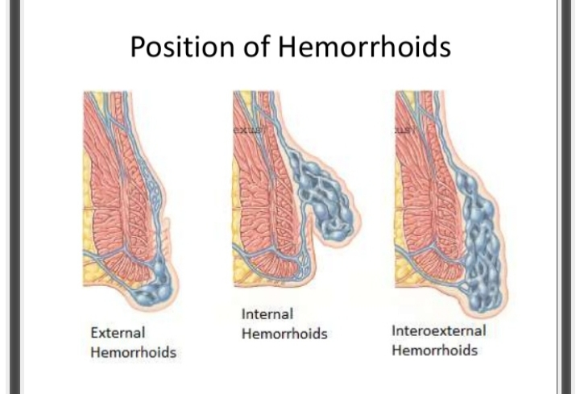
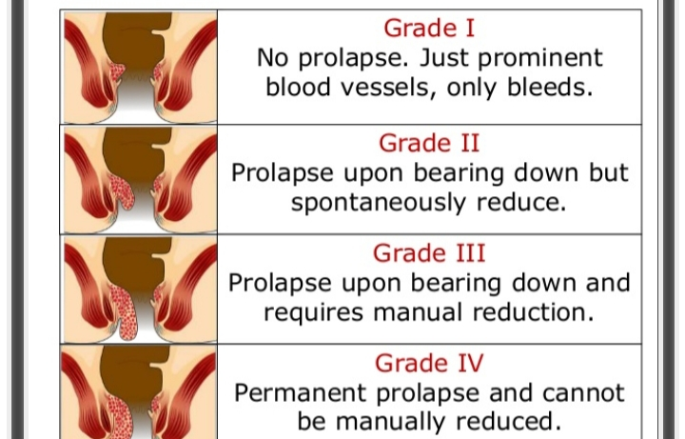
HOMOEOPATHIC Management
1.Aloe socotrina ( Miasm- Psora)
Sore pain in anal region and pain in pelvic can be controlled with this remedy.
Burning sensation in the rectum while passing stools can be controlled effectively.
2.Muriatic Acid(Miasm-psora)
Treatment in extreme cases of piles where the person cannot bear touch.
It is used in cases of large, swollen, purple and blue Hemorrhoids.
3.Hamamellis
This one of the important remedies used to control bleeding caused due to piles.
Pain in lower back and pulsation in the rectum can also be controlled with this remedy.
4.Arsenic album( Miasm – Psoric, syphilitic, sycotic combination)
For patient who experience burning sensation while walking or standing.
Bluish and swollen with lots of bleeding piles are treated by this remedy.
5.sulphur( Miasm- anti-psoric)
It is one of the useful remedies for controlling major symptoms of internal and external piles.
Itching, burning, pain in the anal area can be controlled with it.

Some benefit of homoeopathic treatment.
- HOMOEOPATHIC treatment can curses the piles completely.
- No need to go for surgery
- No chance of reappearing in future.
- Relieves the pain and bleeding just after a few days of treatment.
- It not only curse your piles permanently but also improve your bowel movements clear and relieves constipation.
- It is most safe , genuine , no drug side effect.

