Hahnemann’s Birthday Observation at Midnapore Homoeopathic Medical College & Hospital
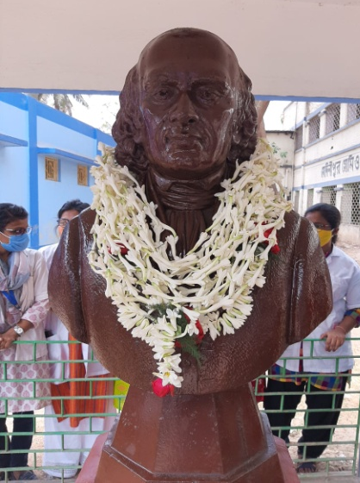 On 10th April 2021, The World Homoeopathy Day, the 267th Birthday Ceremony of Dr. Samuel Hahnemann was observed by Midnapore Homoeopathic Medical College and Hospital, Govt. of West Bengal in befitting manner. The program was initiated by lightning the lamp.
Garlanded Dr. Hahnemann
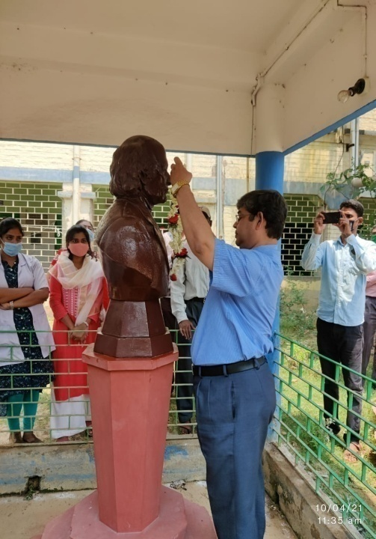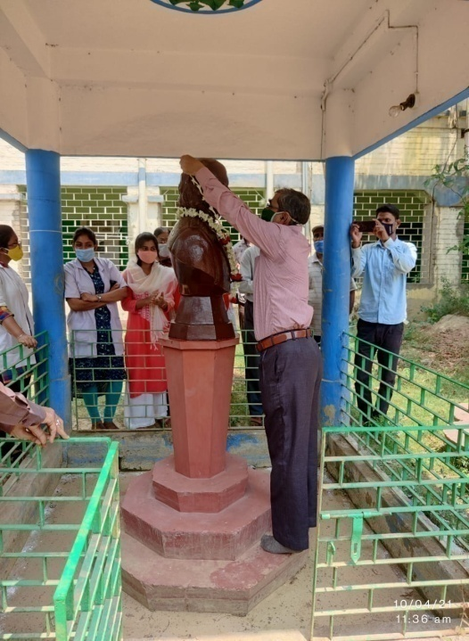
Garlanded by RMO, Dr. Panda
Garlanded by Principal In-Charge, Dr. S. Saha
The garlanding to the statues of Dr. Samuel Hahnemann, in front of IPD section and in the seminar hall was done by all sections of the College and Hospital. The distribution of nutritive food to 79 patients of OPD and 7 patients in IPD were also done.
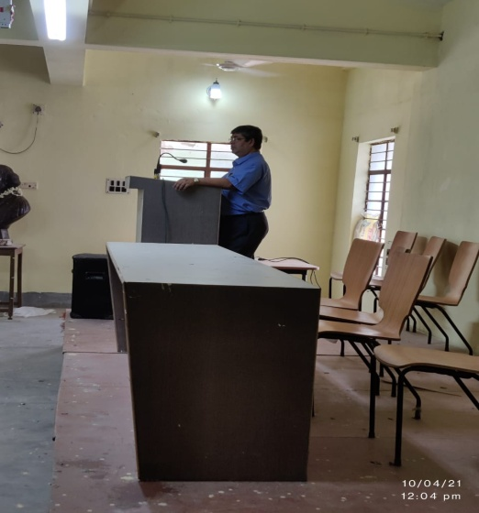
Principal In-Charge on the Podium
Short speeches were delivered by Dr. Srimanta Saha, Principal In-Charge, Dr. B. N. Panda, R.M.O. and Dr. R. Jagdish, part time Lecturer of this Institute about work & contribution of the Father of Homoeopathy, Master Hahnemann. A song was sung by Shruti Gupta, internee. The number of persons who attended the program was almost 80. In this Covid-19 situation the program was very short but in heartfelt atmosphere. Students Union took part actively to success the said program.
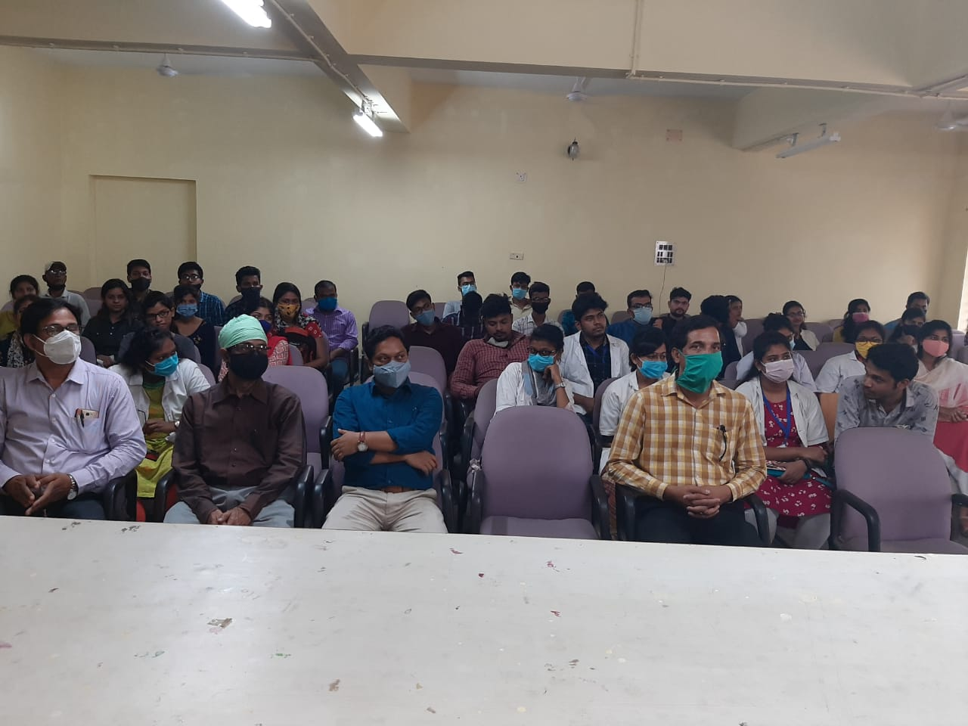
Distinguish Audience at Seminar Hall
Reported by: Dr. Aniruddha Banerjee
Assistant Professor, Dept. of Obs. & Gynae
MHMCH

