Dr Mohinder Singh Jus- An Indian Pioneer
(10th Sept 1947 – 10th June 2019)
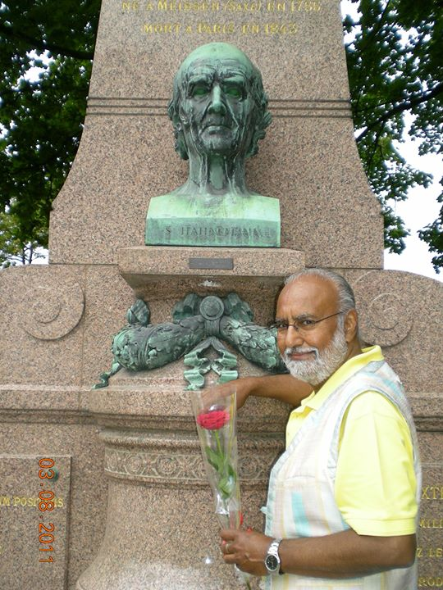

Introduction:
Dr. Mohinder Singh Jus has been a grand teacher of Homoeopathy for over 50 years; He provided selfless service, inspired confidence in his students and always brought a smile on people under his care. He began his teaching career as a commited lecturer at Nehru Homoeopathic Medical College, New Delhi when late Dr. D. P Rastogi was the Principal (1979-1984). He served as an examiner in various Indian universities. He founded the “Homoeopathic Medical Association of India” (HMAI). For eight years he served as Vice-President of New Delhi section. He was also editor-in-chief of HMAI magazine. In 1973, the breakthrough was made, the government gave in and recognized homoeopathy in India. Dr. Jus began his first practice at his home at B9 Kailash Colony in Delhi. He was popular called as “Kidney colic doctor”. He expanded his clinic by opening another clinic in Connaught place, one of the capital’s most vibrant and cosmopolitan locations. His patients varied from laypeople, famous musicians to important high-level politicians and business leaders. Besides this he regularly visited and treated villagers in the vicinity of Delhi for free because social commitment was very important to him.
He was a master prescriber, author of several homoeopathic books, founder of Swiss Homoeopathic Institute (SHI), a pioneering institution in the state of Zug in Switzerland and the man responsible to establish classical homoeopathic practice in Switzerland. He along with his colleague Dr. Dominique Aubry formulated the college’s first curriculum and thus set a training level that became a benchmark throughout Europe. Dr. Kunzli, a well-known Swiss homoeopath and teacher enabled him to teach doctors in homoeopathy for Swiss Association of homoeopathic doctors (SVHA). He was very well known, accepted and respected by homoeopaths, not only in India but all over Europe for his knowledge of homoeopathic materia medica, Homoeopathic philosophy and clinical practice. He worked hard all his life to promote homoeopathy. He initiated the foundation of homoeopathy Association Switzerland (HVS). When Dr. Jus came to Switzerland in 1985, the concept of the profession of a homoeopath simply did not exist. With determination he always began to use the word “the homoeopath” in every seminar and interview. He fought on all fronts to ensure that homoeopathy gains its place as an independent medicine in society. He spared no effort and travelled to all parts of Switzerland to give lay lectures. Many Swiss sportsman who were his patients, not only benefitted immensely from his homoeopathic treatment but they even give testimony in the media. The increasing popularity of homoeopathy alerted the authorities, which repeatedly issued new guidelines for homoeopathic medicines. In 2007, after a 4-year recognition process, the SHI homoeopathy course at the level of the Higher Technical School was recognized by the government council of the canton of Zug. The SHI is the only homoeopathic school in Switzerland that offers state-recognized HF diplomas. Of all his he has written “The Journey of a disease” has been translated into several languages and introduced thousands to the mysteries of homoeopathy. At the hospital Dr Jus was always vibrant, full of humour and spoke with compassion. His encounter with patients would be very short hardly 10 minutes, but the impact it created remained lifelong. The most stubborn cases would resolve under his care & patients remained in remission for months or years together.
Education:
Dr Jus was born to Dr. Gurbax Singh Jus and Mrs Pritam Kaur Jus in New Delhi on 10th September 1947. He was the fourth child out of five. His father was head of art section at American embassy and also a homoeopath. His father would spend a lot of time telling tales with good morals before meals at the dining table. His father was his life teacher. He grew up studying in Summer Fields School at Kailash Colony, where he learned good English and the lesson of giving to the others first. As a young boy he was very good in singing, wonderful painting and desired to be an artist like his brother. Later in college he wanted to be a cricketer. However destiny chose him to paint vivid and detailed pictures of miasms and homoeopathic drug portraits.
As a student of Calcutta Homoeopathic Medical College he came in contact with Dr Bijoy Kumar Bose (Dr. B.K Bose) an excellent teacher in Materia Medica who had direct instructions from Dr J. T Kent from Chicago in USA. Dr Bose instilled in him the love of homoeopathy after which he became Bose’s most favorite student. Dr Jus considered himself to be very lucky to have personal instructions from Dr B.K Bose at Calcutta Homoeopathic Medical College and hospital. He graduated in 1968 with “Diploma of Medicine and Surgery”. After completing his DMS, receiving blessings of his teacher Dr Bose, he returned to Delhi. Dr Jus imbibed the principles, values and skills of Dr Bose in his life & clinical practice. He completed his M.D in Organon of Medicine from Muzzafarpur (Bihar University), India.
He married Martine Cachin (His best student & successor) and was blessed with a son (Manjit) & daughter (Jasmine). His youngest sister Dr. Inderjeet Kaur Jus who lives and practices in Perth (Australia) recalls an incident, when she had gone to visit her brother and he was to deliver a lecture in Bern, Capital of Switzerland, suddenly half way they realized that he had left all the notes at home. She almost panicked whereas Dr Jus just laughed it off & said “Do hell with them, they would have slowed me down, I really don’t need them”. Such was his confidence. When they reached there, at least 800 people were there. The hall was fully booked. Yet Dr. Jus calmly walked the podium and gave a roaring lecture. It was a huge success and people stood up clapping for a few minutes, while his dear sister sat on the edge of her seat.

Connection to India:
He had two private practices from 1969 to 1985 in New Delhi and was vice president of Homoeopathic Medical Association of India. He would see over 120 patients a day and often two patients sought his attention at one time. He would still make time to go to the slums in Delhi and offer his services for free every week. He was a philanthropist in academics and community services. He gave prime importance to service before self. He was so famous that the then Prime Minister Mrs. Indira Gandhi, Mr. Rajiv Gandhi, President of India, top ministers were his patients. He served as a lecturer at Nehru Homoeopathic Medical College, New Delhi till 1985 before he migrated to Switzerland.
Through his friend Dr. M.P Arya from Pune, a well acclaimed academician in the field of homoeopathy. Dr Jus was introduced to the honourable chairman Shri Subhash Shirodkar, of Shri Kamaxidevi Homoeopathic Medical College & Hospital, Goa. In 2004 a memorandum of understanding was signed between SHI, Switzerland and SKHMCH, Shiroda, Goa under academic clinical research programme. Since then every year Dr Jus would visit Shri Kamaxidevi Homoeopathic Medical college and hospital with his team of dedicated doctors for an intensive training programme. His enthralling lectures and clinical sessions impressed everybody, no student would forget the prescribing tips given by him.
During this program Dr. Jus would see over 30 patient’s everyday at the OPD and after lunch the IPD rounds. Further medical camps were organized in rural localities where Dr. Jus with his team would spend the entire day examining hundreds of patients. He always propagated against the harm that vaccinations had done to humans. His concern was India is used as a testing ground for experiments that had proven no good in the west. The patient’s received his advises and tips for lives that were individualized to suit the nature of each patient. I heard him say ‘Exercise is free plastic surgery for your figure’. He was completely against operations which were uncalled for. Since he clearly understood the grave impact they had on the human economy. He also provided wheelchair for handicapped and supported senior citizens with no one to care for.
In 2008 Shri Kamaxidevi Homoeopathic College had organized the 16th National Homoeopathic conference on lifestyle diseases in which Dr Jus was bestowed with “B.K Bose Best Teacher Award” from the hands of health minister for the state of Goa. Dr M. S Jus, an academician to his core, has introduced Gold medal endowment in Goa University in the subject of Organon of Medicine.

Contributions:
1) Dr M. S. Jus as an administrator: Founder of Schule Homoeopathic Institute, Switzerland in 1993 and got homoeopathy recognized and covered under state insurance.
2) Established Dr. B.K Bose Museum in 1993.
3) Dr M.S. Jus as an Author, Writer and Publisher:
Author of Reise einer Krankheit. “Journey of a disease” translated into several languages.
Author of Sport und Homoopathie.
Author of Homoopathische Erste Hilfe.
Author of Praktische Materia Medica, 3 volumes.
Author of Kindertypen in der Homoopathie.
Author of Angststorungen and depressionen.
Founder and Chief Editor of Similia magazine. Also contributed articles to Homoeopathy for everyone medical journal, SKHMC college bulletin, and other reputed medical journals.
4) Established Homoosana manufacturing unit, dealing with a wide range of high potencies.
5) Trained hundreds of homoeopaths for over four decades from all over the world.
6) He lectured regularly in various European countries like Norway, Poland, Finland, Russia, the USA, organized seminars and presented papers on Asthma, Arthritis, M.S, ADHD, etc.
7) Conducted drug proving of Hecla lava, Adonis vernalis, Natrum-Ars, etc
8) Established a homoeopathic botanical garden at SHI containing over 130 different medicinal plants.
Demise:
He lived an extraordinary life and will be remembered for the way he lived. Dr Jus’s sudden demise on 10 June 2019 was very sad news for the entire homoeopathy world especially in Switzerland and India. His wife Dr. Martine Jus is also a dedicated homoeopath with more than 35 years of clinical experiences. She is devoted to the cause of homoeopathy and strives to bring glory to the system, Dr Martine Jus continues the legacy of late Dr Mohinder Singh Jus in spreading the seeds of homoeopathy wherever she goes.

By Dr. Rajiv Rui Viegas Peres

