A CASE OF ULCER ON RIGHT LEG
AUTHORS
Dr. Jaharlal Barman, Dr. Aditi Paul
ABSTRACT
A case of ulcer on right leg treated effectively with the Homoeopathic medicine with proper management showing the efficacy of Homoeopathy in chronic disease.
Key wards
Ulcer, surgical skin disease, advance homoeopathic treatment INTRODUCTION :
An ulcer is a discontinuity of the skin or mucous membrane which occurs due to microscopic death of the tissues. Thus, ulcer can occur any where in the body (skin), oral cavity, penis (mucous membrane) or in the duodenum, intestine, etc.
CASE PRESENTATION :
Presenting symptom:
Mrs. R. Shaw, 55 years of age, a housewife visited our OPD on 7/5/2019 with ulcer over inter malleolar area of right leg for 10 days.
History of present complaint :
Previously a small boil was found on that area for 1months. Suddenly over night she found a round punch out ulcer and she used some ointment for last few days.
On examination:
Ulcer was round in shape, tender, having sticky reddish discharges, sensitive to touch.
Case in brief:
On case taking patient was suffering from severe itching followed by burning sensation and then became painful. P/H-Skin disease suppression, F/H- Copd of her father; Desire for sweet, cannot tolerate hunger, all discharges are offensive and acrid leucorrhoea. Hot patient and patient was unclean. On the basis of these symptoms I prescribed Sulphur 30/1dose.

Follow up:
- On 21/5/2019- Ulcer started to heal. Burning sensation and itching were also decreasing.
- On 28/5/2019- Ulcer was completely healed.

DISCUSSION AND SUMMERY :
The case shows the efficacy of proper homoeopathic treatment with minimum dose can cured so called chronic skin disease and further establishes the internal nature of the so-called external diseases and without surgical intervention or any other external applications the ulcer can be cure by proper Homoeopathic treatment.

Patient’s perspective:
Patient was very much pleased for removing the ulcer by homoeopathic treatment.

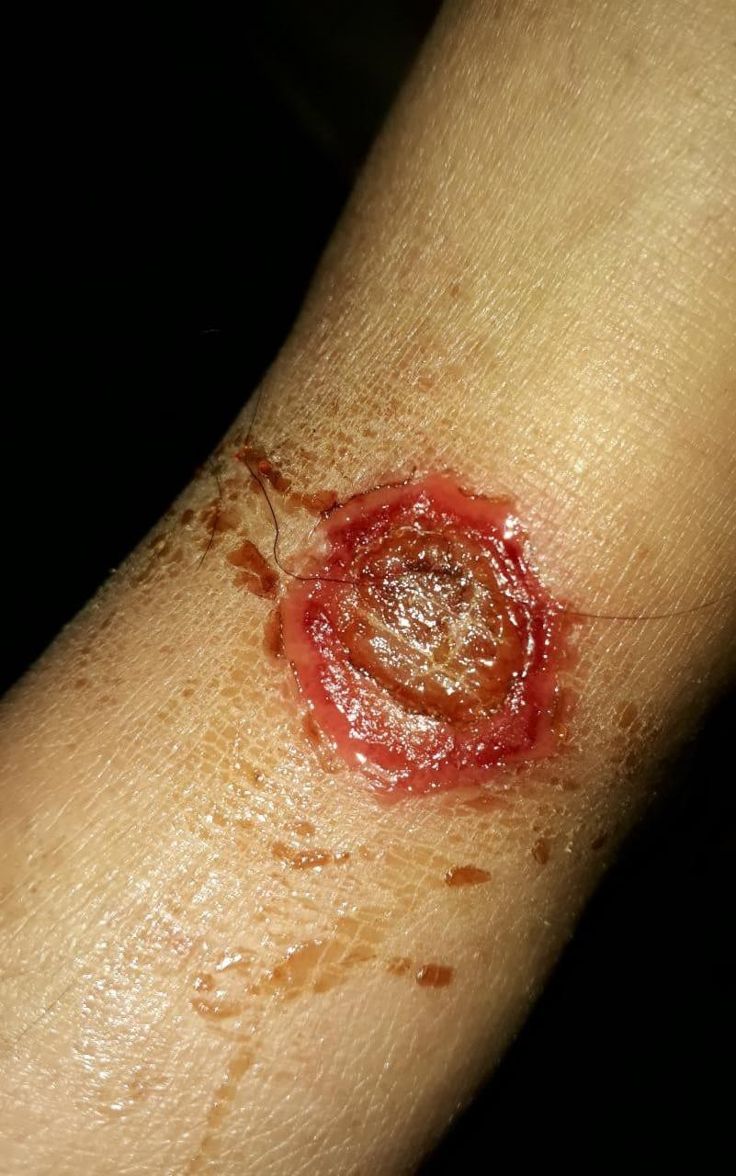

BEFORE [Fig-1 on7/5 /2019(1stvisit)]

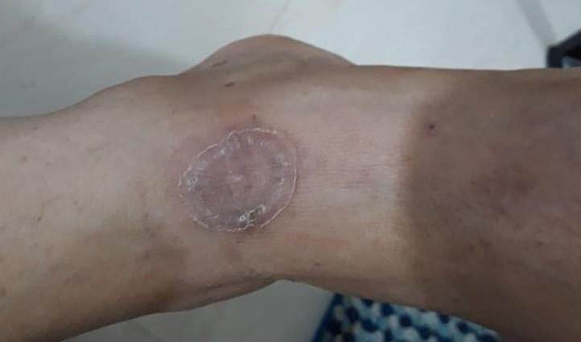
AFTER [Fig-28/5/2019(3rd visit)

References:
- Shenoy K. Rajgopal Nileshwar Anitha Manipal Manual of Surgery. 3rd ed. CBS Publishers 7 Distributors Pvt Ltd.
- Hahnemann’s Organon of Medicine 5th & 6th edition. Low price Edition. New Delhi: B. Jain publishers Pvt. Ltd; 2002.
- Ulcer on skin. Available from: https://www.medicalnewstoday.com/articles/324466#causes. [ Access on 02.03.2022]

