A CASE OF BEHAVIOUR DISORDER OF A SORROWFUL GIRL
Dr. NISHANT GUPTA

A 19-YEAR-OLD YOUNG GIRL PATIENT CAME TO MY CLINIC WITH HIS FATHER.
HISTORY
Her father on previous day told me a bit of history that his daughter had behavior problem and that’s why she was dropped out from school the previous year. She neglects doing her own routine work and has some sleep disturbance as well.
The girl entered my chamber with very pity and sorrow face. Even I was feeling guilt when saw her.
COVERSATION
D: How are you miss? What happen to you.
(After some time, patient talks in low voice)
P: I feel the irritation all the times. Can’t sleep well. Got lazy easily.
D: What bothering the most?
P: Taking the large doses of allopathic medicines. I don’t like taking the medicines. I have a fear it didn’t suits me.
D: Soo?
P: Again, I have to repeatedly take the medicines.
D: What is your routine all day around?
(In order to communicate her more. She was a very introverted girl.)
P: I use to wake up early in the morning at 6 am. Then I exercise according to my mother (her face became duller). Then I go to the tuition in morning. Then I came back to tuition for lunch. After then I do my homework given in tuition. Then I see some movies, generally I like horror movies and comedy shows. As they have some thrill in it. Then I go to the sleep by 10 PM.
D: Do u like doing exercise?
(As I show her changed facial expression at that time)
P: I want do exercise by my own. But my mother always use to force me up to do exercise by her will. It irritates and disturbs me the most. She always use force me to do exercise where as I also know how to exercise by myself.
D: How does you feel at that time?
P: I feel like trapped. She always used to force me according her will. I wanted to do it my way out. I have learnt exercised by watching YouTube. I know more that her why should I listen to her.
D: Anything more which bothers you?
P: My sister irritates me a lot. She use to mock me a lot.
D: How?
P: She use to dirty the kitchen all the time. She didn’t know cooking but she
does things. She use to watch T.V. at high volume.
D: Why did you dropped out from the school?
(Her school was in south India. She use to live in a hostel)
P: People there irritates me a lot there.
D: How?
P: There were a group of girls who use to always complain about me. I use to eat meal all the time. But they use to complain the warden that I haven’t eat the meal.
D: Then?
P: The warden use to scold me. Then I have to forcefully eat the meal again.
I feel harassed because of that.
(HER FACE BECAME SORROWFULL AND DULL AGAIN)
ANALYSIS
KINGDOM
In this case got the major theme of victim and aggressor.
I VS THE OTHER was very prominent.
Issues of survival was there.
CONSULTION:
This is an Animal.
CLASS AVES
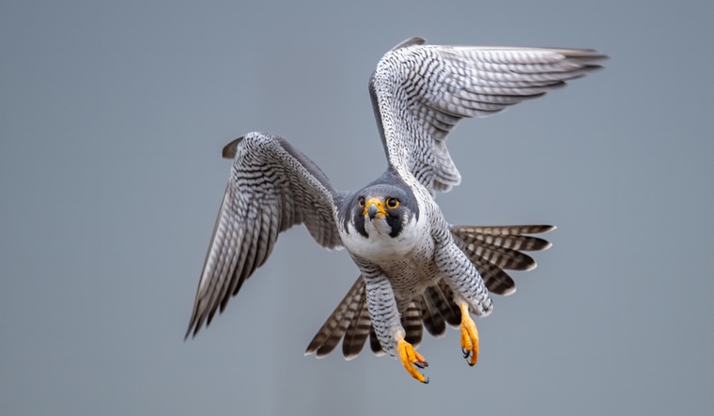
KEYWORDS.
TRAPPED
FREE OF RESPONSIBILITIES
FIGHT
CONTROL
DOMINATION
CORE RUBRIC
[Complete ] [Mind]ANXIETY:Do something, when compelled to:
3 Bry, 1 Carc, 1 Falco-p, 1 Strept
INTERPRETATION:-
She felt the anxiety when she was forcefully doing the task. That the major core of the case.

Totality

REMEDY:
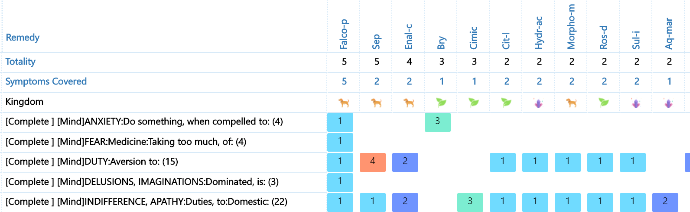
REMEDY:
Falco Peregrinus Disciplinatus 1M ( single dose)
(16-12-19)

Follow up 1st
(12-02-20)

She came with smile to my clinic.
P: I am ok now. Irritation has reduced. Now my mother listens to me now. I use to do things by my own.
Patient Father: She has started a bit of household work now. She use to do exercise by her own. But her sleep didn’t improved that much.
THEN I REPEATED Falco-p 1M (SINGLE DOSE) AGAIN.
(12-02-20)
Follow up 2nd : (7-03-20)
P: I now had good concentration as well. Having a nice sleep now. Irritation is much less. Sleep is good as well. Thanks a lot doctor for your support.
FOLLOW UP 3rd:

(23-07-20)

Sleep was better. Her mother and she had a good bond now. She has reduced 7kg weight as well. As she does exercise regularly.

What more important was constant smile in her face, that amuse me a a lot.

ABOUT ME:
Myself Dr. NISHANT GUPTA a passionate young homoeopath from Raipur Chhattisgarh. My cases results have been evaluated by practicing the sensation method. I found myself fortunate to be in this great science that divines the life of a person.
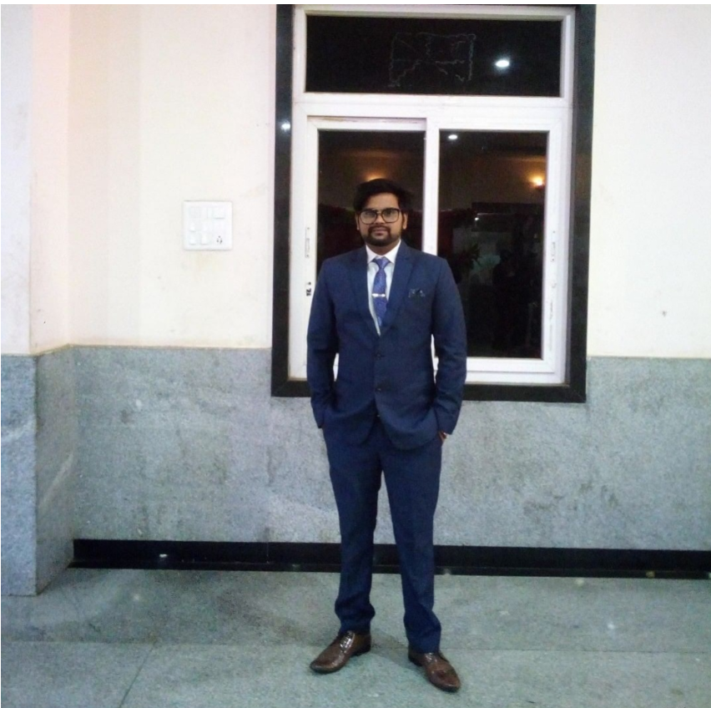
Dr. NISHANT GUPTA
EMAIL- nishant25smilebox@gmail.com

